ISLAMIC UNIVERSITY OF TECHNOLOGY
Organization of Islamic Cooperation
Board Bazar, Gazipur

Geometry of
Linear Algebra
MATH 4341
Md. Mohsinul Kabir

Problem 1
$u_{0}=\left[\begin{matrix}1 \\ 0\end{matrix}\right]$ $A=\left[\begin{matrix}0.8 & 0.3 \\ 0.2 & 0.7\end{matrix}\right]$
$$u_{1}=\left[\begin{matrix}0.8 & 0.3 \\ 0.2 & 0.7\end{matrix}\right]⋅\left[\begin{matrix}1 \\ 0\end{matrix}\right]=\left[\begin{matrix}0.8 \\ 0.2\end{matrix}\right]$$
$$u_{2}=\left[\begin{matrix}0.8 & 0.3 \\ 0.2 & 0.7\end{matrix}\right]⋅\left[\begin{matrix}0.8 \\ 0.2\end{matrix}\right]=\left[\begin{matrix}0.7 \\ 0.3\end{matrix}\right]$$
$$u_{3}=\left[\begin{matrix}0.8 & 0.3 \\ 0.2 & 0.7\end{matrix}\right]⋅\left[\begin{matrix}0.7 \\ 0.3\end{matrix}\right]=\left[\begin{matrix}0.65 \\ 0.35\end{matrix}\right]$$
Observations:
- Top row decreases and bottom row increases
- Change in top row $=$ Change in bottom row
- Sum of columns $=1$ (Markov Matrices)

Problem 2
$v=\left[\begin{matrix}3 \\ 4\end{matrix}\right]$ $\left|\left|v\right|\right|=\sqrt{3^{2}+4^{2}}=5$
$w=\left[\begin{matrix}4 \\ 3\end{matrix}\right]$ $\left|\left|w\right|\right|=\sqrt{4^{2}+3^{2}}=5$
$$v⋅w=\left[\begin{matrix}3 \\ 4\end{matrix}\right]⋅\left[\begin{matrix}4 \\ 3\end{matrix}\right]=\left(3×4\right)+\left(4×3\right)=24$$
$$\left|\left|v\right|\right|⋅\left|\left|w\right|\right|=5×5=25$$
$$v+w=\left[\begin{matrix}3 \\ 4\end{matrix}\right]+\left[\begin{matrix}4 \\ 3\end{matrix}\right]=\left[\begin{matrix}7 \\ 7\end{matrix}\right]$$
$$\left|v+w\right|=\sqrt{7^{2}+7^{2}}=7\sqrt{2}$$
$$\left|\left|v\right|\right|+\left|\left|w\right|\right|=5+5=10$$
The Schwarz inequality states
$$v⋅w≤\left|\left|v\right|\right|⋅\left|\left|w\right|\right|$$
$$24≤25$$
The triangular inequality states
$$\left|v+w\right|≤\left|\left|v\right|\right|+\left|\left|w\right|\right|$$
$$7\sqrt{2}≤10$$
Both inequalities are proven.
We know, $v⋅w=\left|\left|v\right|\right|⋅\left|\left|w\right|\right|⋅\cos{θ}$
$$\cos{θ}=\frac{24}{25}$$
Problem 3
$$a=\frac{w}{\left|\left|w\right|\right|}$$
$$\left|\left|w\right|\right|=\sqrt{4^{2}+3^{2}}=5$$
$$∴a=\left(\frac{4}{5},\frac{3}{5}\right)$$
Vector $b=\left[\begin{matrix}-3 \\ 4\end{matrix}\right]$ is perpendicular to $w$ since
$$b⋅w=\left[\begin{matrix}-3 \\ 4\end{matrix}\right]⋅\left[\begin{matrix}4 \\ 3\end{matrix}\right]=-12+12=0$$
$$\left|\left|b\right|\right|=\sqrt{{\left(-3\right)}^{2}+4^{2}}=5$$
$$∴v=\left(-\frac{3}{5},\frac{4}{5}\right)$$
There is only one other possibility for $v$, i.e. $v=\left(\frac{3}{5}, -\frac{4}{5}\right)$.

Problem 4
a) $\left[\begin{matrix}2 \\ 3 \\ 4\end{matrix}\right]$ and $\left[\begin{matrix}5 \\ 8 \\ 11\end{matrix}\right]$ are linearly independent, so all their combinations will be a plane in $R^{3}$.
b) $\left[\begin{matrix}1 \\ 0 \\ 0\end{matrix}\right]$ and $\left[\begin{matrix}0 \\ 3 \\ 4\end{matrix}\right]$ are linearly independent, so all their linear combinations will be a plane in $R^{3}$.
c) $\left[\begin{matrix}2 \\ 0 \\ 0\end{matrix}\right]$, $\left[\begin{matrix}0 \\ 2 \\ 2\end{matrix}\right]$ and $\left[\begin{matrix}2 \\ 2 \\ 3\end{matrix}\right]$ are linearly independent, so all their linear combinations will be a plane in $R^{3}$.

Problem 5
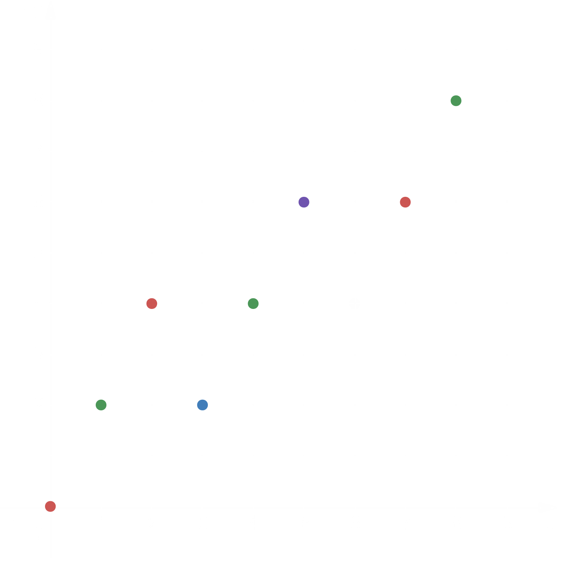

$$a=0\left[\begin{matrix}3 \\ 2\end{matrix}\right]+0\left[\begin{matrix}1 \\ 2\end{matrix}\right]=\left[\begin{matrix}0 \\ 0\end{matrix}\right]$$
$$b=0\left[\begin{matrix}3 \\ 2\end{matrix}\right]+1\left[\begin{matrix}1 \\ 2\end{matrix}\right]=\left[\begin{matrix}1 \\ 2\end{matrix}\right]$$
$$c=0\left[\begin{matrix}3 \\ 2\end{matrix}\right]+2\left[\begin{matrix}1 \\ 2\end{matrix}\right]=\left[\begin{matrix}2 \\ 4\end{matrix}\right]$$
$$d=1\left[\begin{matrix}3 \\ 2\end{matrix}\right]+0\left[\begin{matrix}1 \\ 2\end{matrix}\right]=\left[\begin{matrix}3 \\ 2\end{matrix}\right]$$
$$e=1\left[\begin{matrix}3 \\ 2\end{matrix}\right]+1\left[\begin{matrix}1 \\ 2\end{matrix}\right]=\left[\begin{matrix}4 \\ 4\end{matrix}\right]$$
$$f=1\left[\begin{matrix}3 \\ 2\end{matrix}\right]+2\left[\begin{matrix}1 \\ 2\end{matrix}\right]=\left[\begin{matrix}5 \\ 6\end{matrix}\right]$$
$$g=2\left[\begin{matrix}3 \\ 2\end{matrix}\right]+0\left[\begin{matrix}1 \\ 2\end{matrix}\right]=\left[\begin{matrix}6 \\ 4\end{matrix}\right]$$
$$h=2\left[\begin{matrix}3 \\ 2\end{matrix}\right]+1\left[\begin{matrix}1 \\ 2\end{matrix}\right]=\left[\begin{matrix}7 \\ 6\end{matrix}\right]$$
$$i=2\left[\begin{matrix}3 \\ 2\end{matrix}\right]+2\left[\begin{matrix}1 \\ 2\end{matrix}\right]=\left[\begin{matrix}8 \\ 8\end{matrix}\right]$$
Problem 6
Combination 1: $u+w-v=b$
Combination 2: $v-2u+0w=b$
Any three vectors may not always produce $b$. They will fail to do so if all three are on lines that do not contain $b$.

Problem 7
$1c+0d+0e=2$ - ($i$)
$1c+1d+0e=5$ - ($ii$)
$1c+1d+1e=9$ - ($iii$)
From equation ($i$), $c=2$
From equation ($ii$), $c+d=5$
$d=5-2$
$d=3$
From equation ($iii$), $c+d+e=9$
$e=9-3-2$
$e=4$

Problem 8
The vectors $u=\left[\begin{matrix}1 \\ 1 \\ 1\end{matrix}\right]$, $v=\left[\begin{matrix}2 \\ 2 \\ 2\end{matrix}\right]$ and $w=\left[\begin{matrix}3 \\ 3 \\ 3\end{matrix}\right]$ would form only a line.
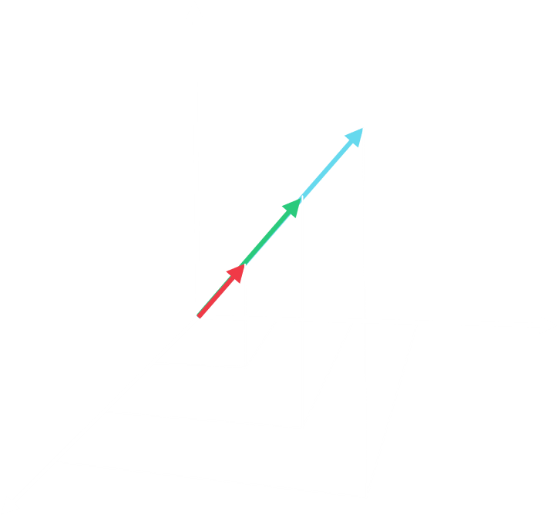
The vectors $u=\left[\begin{matrix}1 \\ 1 \\ 1\end{matrix}\right]$, $v=\left[\begin{matrix}2 \\ 2 \\ 2\end{matrix}\right]$ and $w=\left[\begin{matrix}3 \\ 1 \\ 2\end{matrix}\right]$ would form a plane.
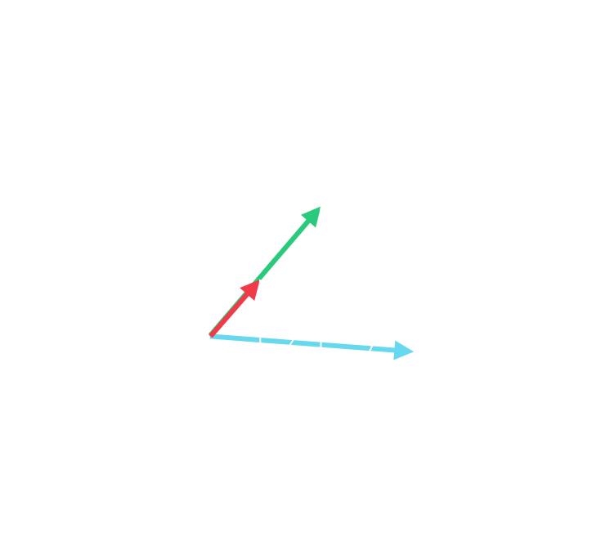
Problem 9
The other four corners are $\left(0, 1, 1\right)$, $\left(1, 0, 1\right)$, $\left(1, 1, 0\right)$ and $\left(1, 1, 1\right)$.
The centre of the cube is $\left(\frac{1}{2},\frac{1}{2},\frac{1}{2}\right)$.
The centre points of the $6$ faces are:
$\left(0,\frac{1}{2},\frac{1}{2}\right)$, $\left(\frac{1}{2},\frac{1}{2}, 0\right)$, $\left(\frac{1}{2}, 0,\frac{1}{2}\right)$, $\left(\frac{1}{2},\frac{1}{2}, 1\right)$, $\left(1,\frac{1}{2},\frac{1}{2}\right)$ and $\left(\frac{1}{2}, 1,\frac{1}{2}\right)$.

